Date 04.04.2024

<https://docs.aws.amazon.com/global-accelerator/>

**AWS Global Accelerator Documentation**

AWS Global Accelerator is a network layer service in which you create accelerators to improve the security, availability, and performance of your applications for local and global users. Depending on the type of accelerator that you choose, you can gain additional benefits, such as improving availability or mapping users to specific destination endpoints.

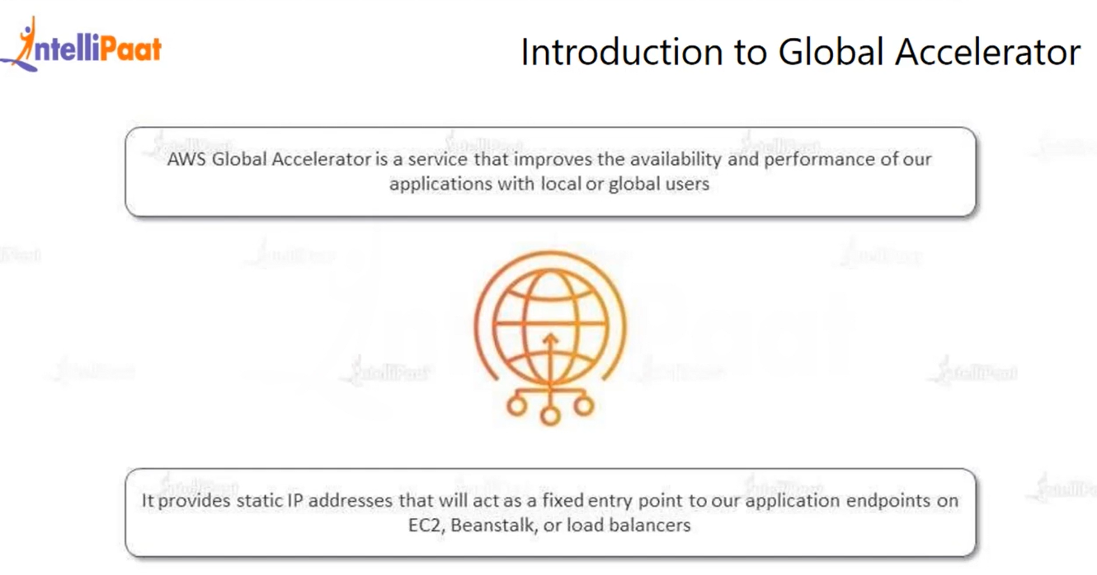

With Global accelerator we can increase the performance of the applications.

We can decrease the downtime

We can make it highly available

AWS Global Accelerator is a service in which you create accelerators to improve the performance of your applications for local and global users. Depending on the type of accelerator you choose, you can gain additional benefits:

* With a standard accelerator, you can improve availability of your internet applications that are used by a global audience. With a standard accelerator, Global Accelerator directs traffic over the AWS global network to endpoints in the nearest Region to the client.
* With a custom routing accelerator, you can map one or more users to a specific destination among many destinations.

Global Accelerator is a global service that supports endpoints in multiple AWS Regions. To determine if Global Accelerator or other services are currently supported in a specific AWS Region, see the [AWS Regional Services List](https://aws.amazon.com/about-aws/global-infrastructure/regional-product-services/)

.

By default, Global Accelerator provides you with static IP addresses that you associate with your accelerator. The static IP addresses are anycast from the AWS edge network. For IPv4, Global Accelerator provides two static IPv4 addresses. For dual-stack, Global Accelerator provides a total of four addresses: two static IPv4 addresses and two static IPv6 addresses. For IPv4, instead of using the addresses that Global Accelerator provides, you can configure these entry points to be IPv4 addresses from your own IP address ranges that you bring to Global Accelerator (BYOIP).

The static IP addresses remain assigned to your accelerator for as long as it exists, even if you disable the accelerator and it no longer accepts or routes traffic. However, when you delete an accelerator, you lose the static IP addresses that are assigned to it, so you can no longer route traffic by using them. You can use IAM policies, like tag-based permissions with Global Accelerator, to limit the users who have permissions to delete an accelerator. For more information, see [ABAC with Global Accelerator](https://docs.aws.amazon.com/global-accelerator/latest/dg/security_iam_service-with-iam.html#security_iam_service-with-iam-tags).

For standard accelerators, Global Accelerator uses the AWS global network to route traffic to the optimal regional endpoint based on health, client location, and policies that you configure, which increases the availability of your applications. Endpoints for standard accelerators can be Network Load Balancers, Application Load Balancers, Amazon EC2 instances, or Elastic IP addresses that are located in one AWS Region or multiple Regions. The service reacts instantly to changes in health or configuration to ensure that internet traffic from clients is always directed to healthy endpoints.

Custom routing accelerators only support virtual private cloud (VPC) subnet endpoint types and route traffic to private IP addresses in that subnet.

**Create accelerator**

Get started by creating an accelerator to optimize traffic to your applications. You create accelerators by using the AWS Global Accelerator console. AWS Global Accelerator is a global service that supports endpoints in a single or multiple AWS Regions.

Now Create the Global accelerator

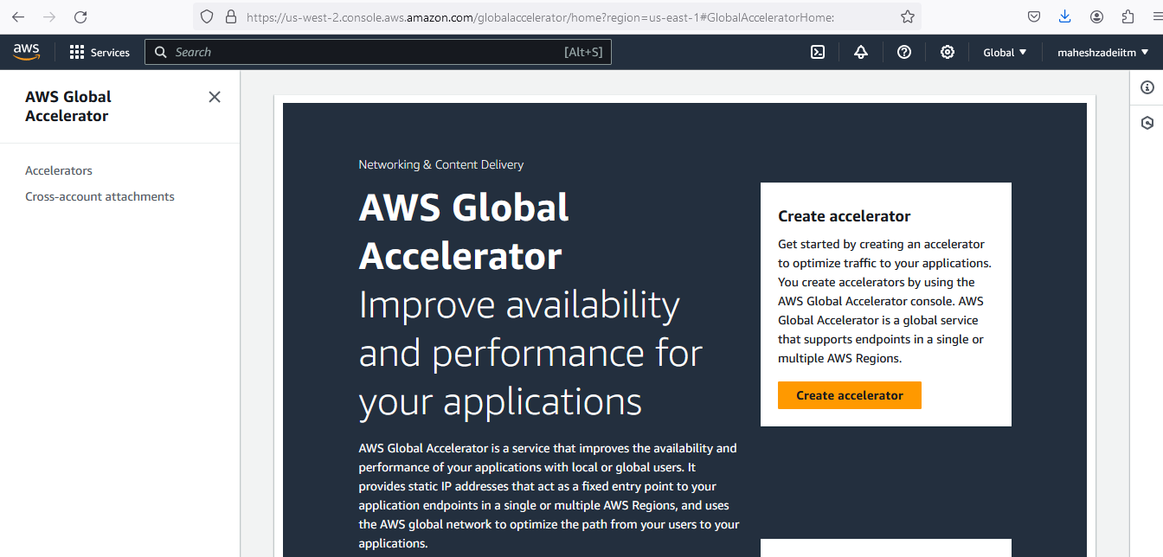

https://speedtest.globalaccelerator.aws/#/

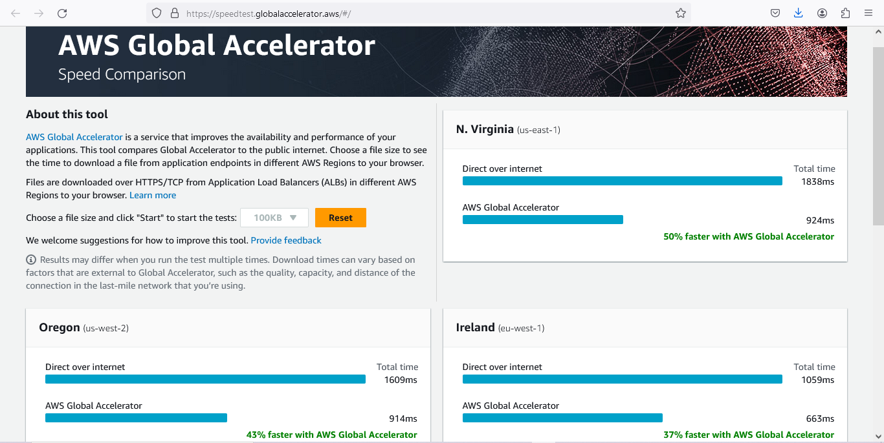

Now Go to AWS Console and create the AWS Global Accelerator

First we have create the EC2 Instance in two different regions

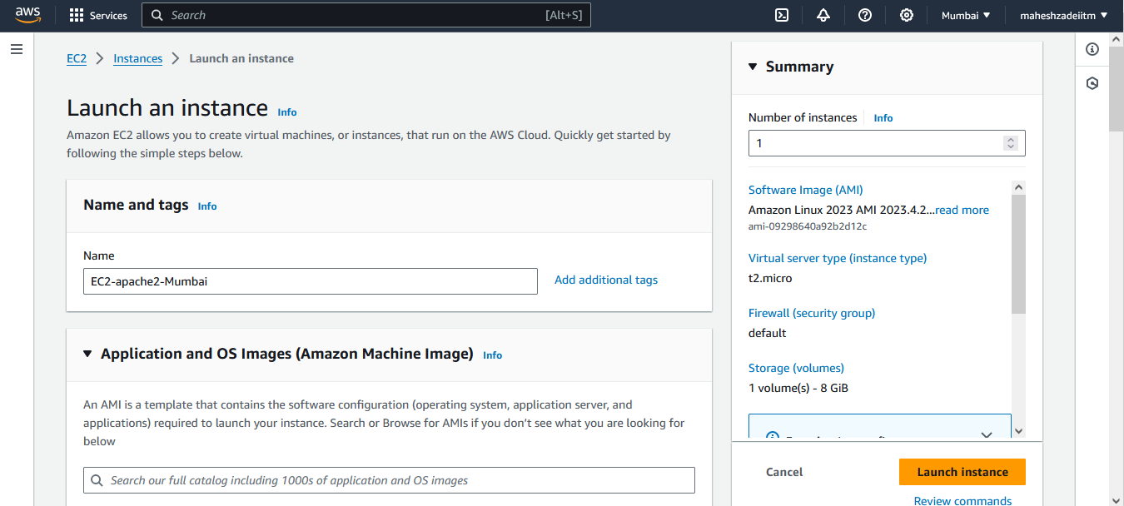

Go to User data and add a script for apache2 server

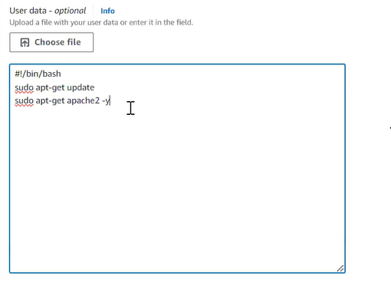

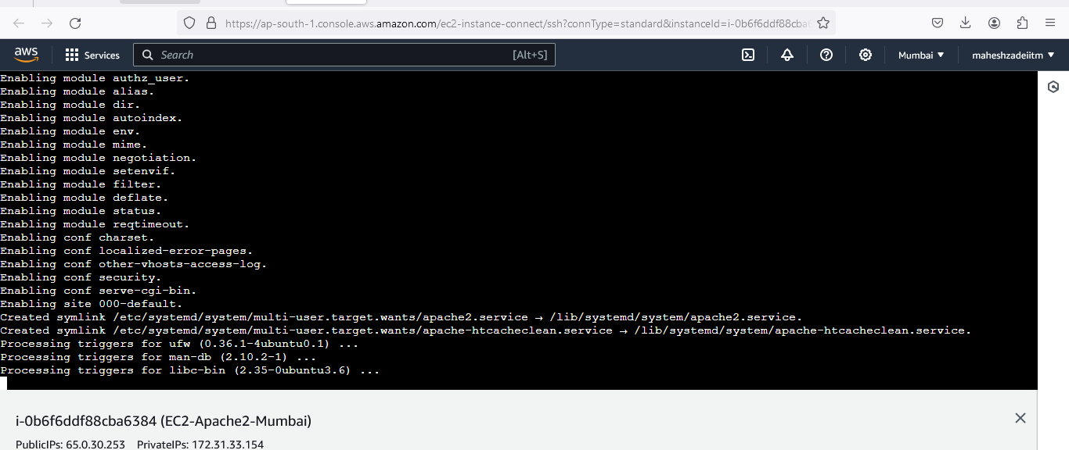

Now go to Tokyo Region and create the Nginx Server

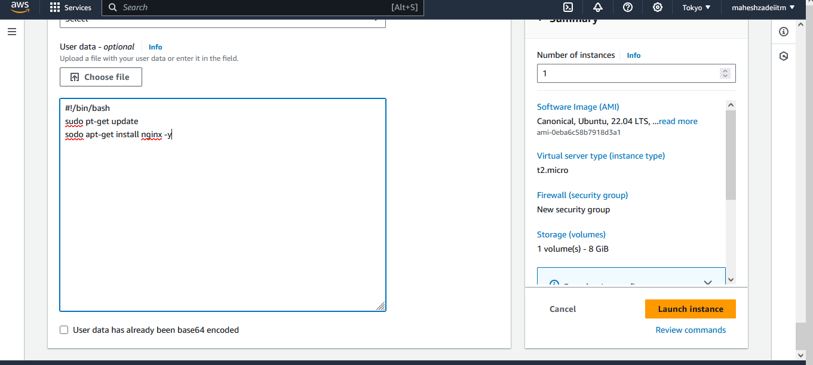

Lauch instance

Chek both the server now

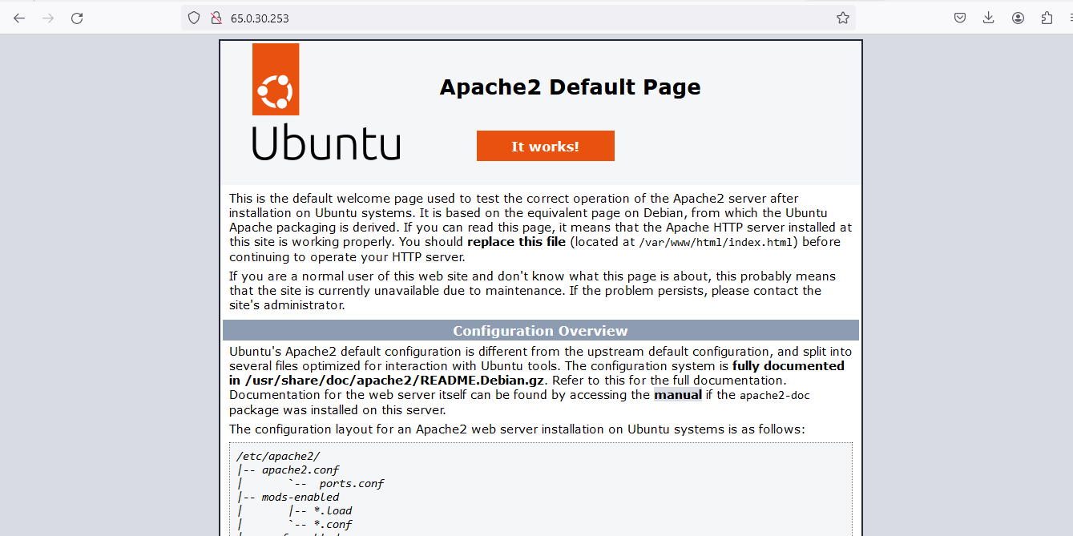

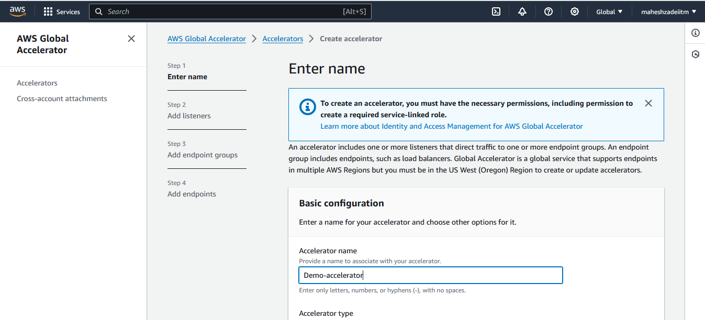

**Change Health check protocol to http**

**add another end point group**

**Change health check protocol to http from TCP**

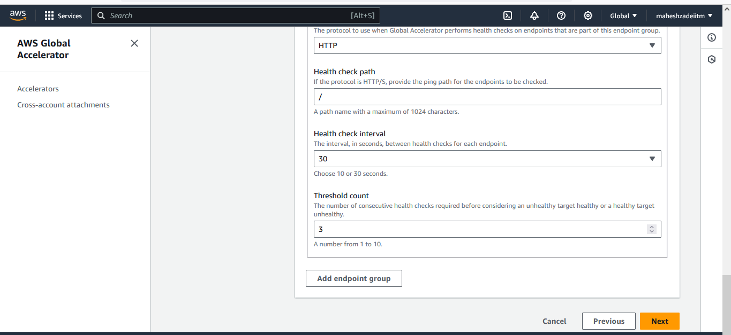

**And click on next**

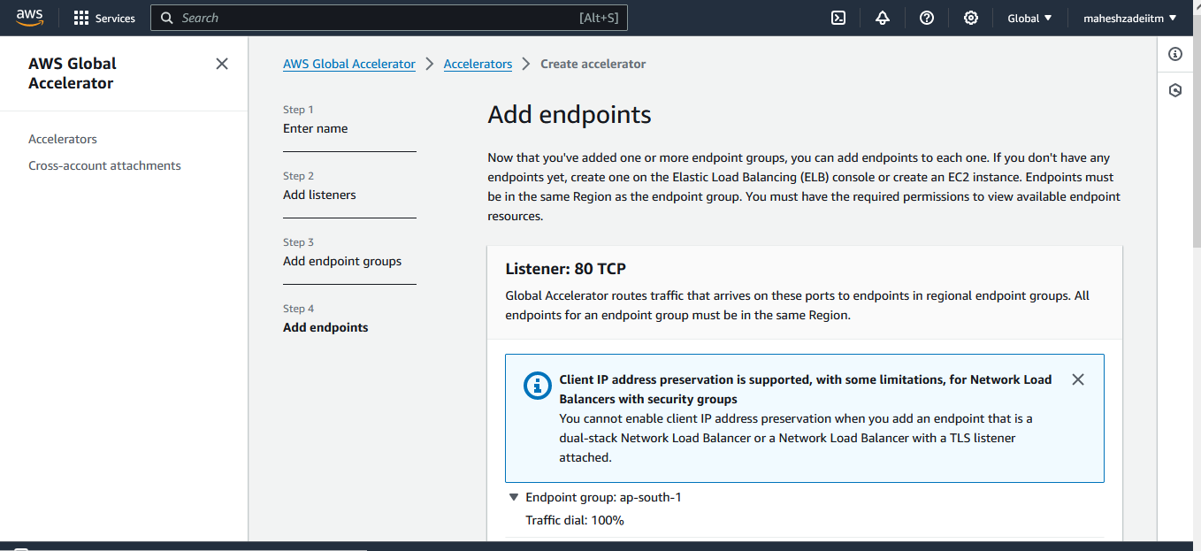

**Click create acceleratot**

**End points to route the traffic**

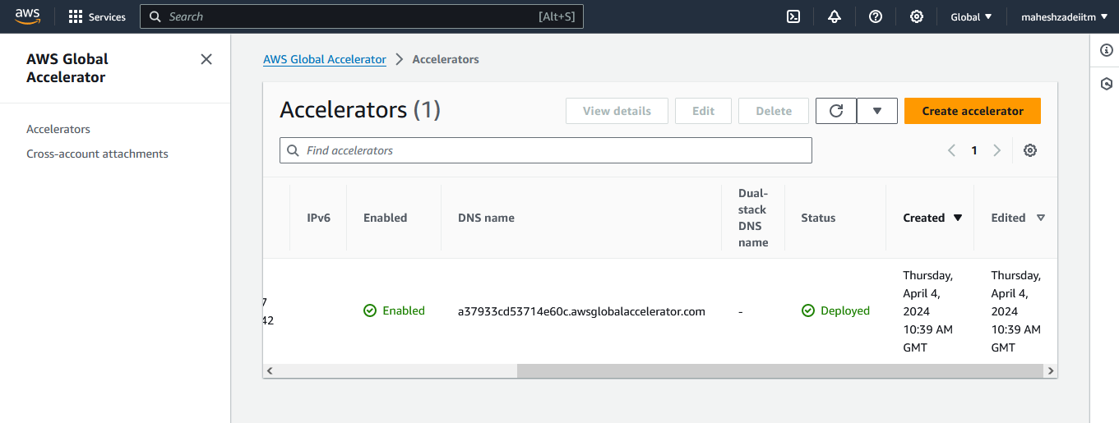

**DNS Name :**

[**http://a37933cd53714e60c.awsglobalaccelerator.com/**](http://a37933cd53714e60c.awsglobalaccelerator.com/)

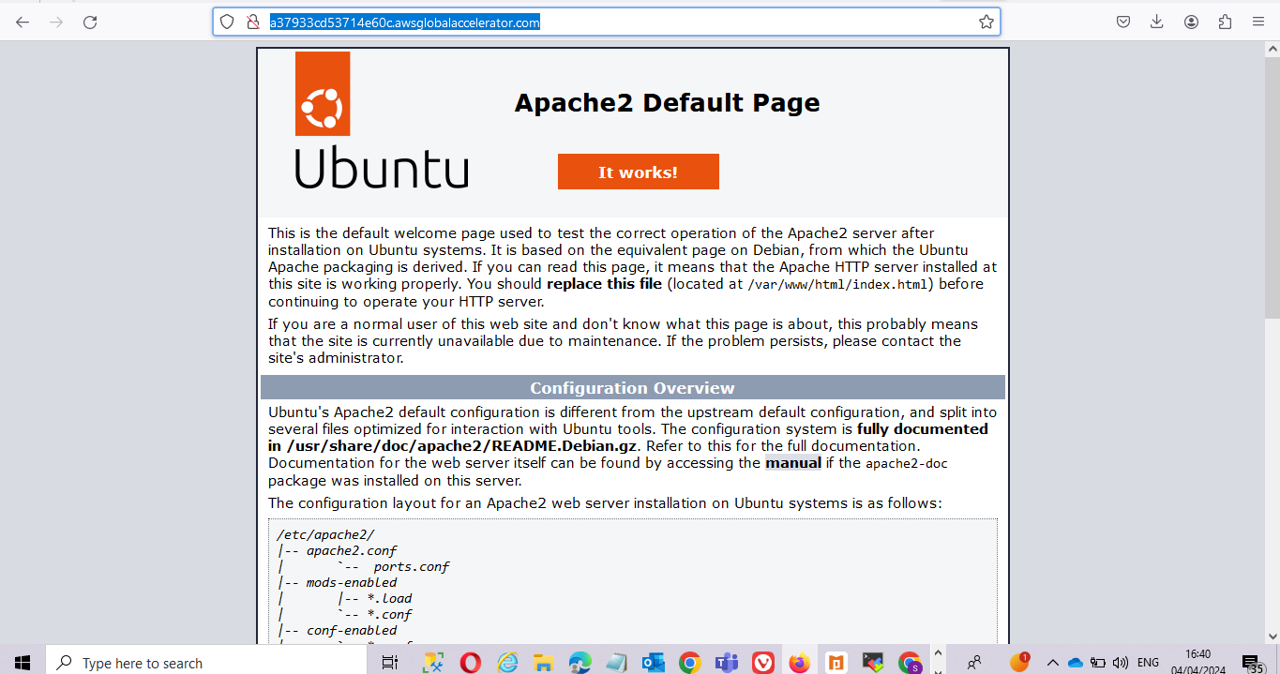

**I have successful done hands on Global Accelerator**

**Thanks**